Video Resources for help
Jeremy Krug
Michael Farabaugh

Topic 1.3: Elemental Composition of Pure Substances
Topic 1.4: Composition of Mixtures

- A 66.0 g sample of a compound contains 36.0 g of C, 6.00 g of H, and 24.0 g of O. Determine the empirical formula.

- A compound contains 0.75 moles of K, 0.75 moles of Cr, and 2.6 moles of O. What is the simplest formula of the compound?

- In an experiment, a student is assigned the task of determining the number of moles of water in one mole of the hydrate Na₂SO₄ • nH₂O. The student collects the data shown in the following table.

Mass of empty container | 22.347 g
Initial mass of sample and container | 25.959 g
Mass of sample and container after first heating | 24.677 g
Mass of sample and container after second heating | 23.941 g
Mass of sample and container after third heating | 23.940 g

  - Explain why the sample was heated three times.

  - Explain why the student can conclude that all of the water was driven off of the hydrate.

  - Use the data above to …
    - Determine the mass of the sample before heating.

    - Determine the mass of water in the sample.

    - Determine the moles of water in the sample.

    - Determine the mass of anhydrate in the sample.

    - Determine the moles of anhydrate in the sample

    - Determine the formula of the hydrated compound.

- Answer the following questions about a 1.745 g sample of CaSO₄ • 2H₂O.
  - What percent of the hydrate is water?

  - How many grams of water are present in the compound?

  - The sample is placed in a crucible that weighs 22.35 g. The crucible is heated to constant mass. What would be the mass of the crucible and anhydrate?

- A sample of brass weighing 1.203 grams was analyzed. Brass is an alloy composed of copper, Cu, and zinc, Zn. The zinc in the alloy was reacted with 35.123 grams of hydrochloric acid, HCl, in excess, according to the following balanced equation:
Zn_{(s)} + 2 HCl _{(aq)} → H_{2 (g)} + ZnCl_{2 (aq)}
After all of the zinc reacted the mass of the remaining solution weighed 36.309 grams.

  - What mass of hydrogen gas was produced?

  - What mass of zinc reacted?

  - What was the percentage of zinc (by mass) in the alloy?

- A sample of sodium bromide, NaBr, has a mass percentage of sodium of 22.34%.

  - If the sample of sodium bromide were contaminated with sodium chloride, NaCl, would the mass percentage of Na in the sample be higher or lower than the pure sample? Justify your claim.

  - If the sample of sodium bromide were contaminated with sodium iodide, NaI, would the mass percentage of Na in the sample be higher or lower than the pure sample? Justify your claim.

Topic 1.5: Atomic Structure and Electron Configuration

- Give the complete electron configuration of the following atoms and ions.
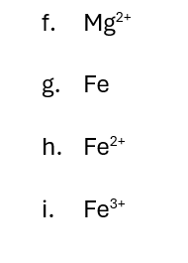
- Zn

- Zn²⁺

- P

- P³⁻

- Mg

- According to Coulomb’s Law, does the force of attraction/repulsion increase, decrease, or remain the same when …
  - the distance between the charges increases?

  - the distance between the charges decreases?

  - the magnitude of the charges increases?

  - the magnitude of the charges decreases?

- What are the electron configuration exceptions for Copper and Chromium and why do they occur?

Topic 1.7: Periodic Table Trends
Topic 1.8: Valence Electrons and Ionic Compounds

- What happens to the number of protons in the nucleus as you move from left to right across a period on the periodic table?

- An electron is removed from an atom. Would it take more energy, less energy, or the same amount of energy to remove an electron …
  - closer to the nucleus? Explain your reasoning.

  - further from the nucleus? Explain your reasoning.

- Using the concept of effective nuclear charge, explain why the size of the atom generally decreases when going from left to right across the periodic table.

- Explain why a cation is smaller than its atom and a anion is larger that its atom?

- Explain how Coulomb’s law can help explain ionization energy.

- Consider the ionization energy to remove an electron from a neutral atom, X. Would you expect the ionization energy to increase, decrease, or stay the same if …
- an electron is removed from an identical neutral atom, X? Explain your reasoning.

- an electron is removed from an X cation, X⁺ ? Explain your reasoning.

- an electron is removed from an X anion, X⁻? Explain your reasoning.

- an electron is removed from a different, larger atom? Explain your reasoning.

- an electron is removed from a different atom in the same period with more protons. Explain your reasoning.

- an electron is removed from a different atom in the same group with fewer protons. Explain your reasoning.
- The successive ionization energies of Al are shown below.

1st ionization energy | 2nd ionization energy | 3rd ionization energy | 4th ionization energy
578 kJ/mol | 1820 kJ/mol | 2750 kJ/mol | 11,600 kJ/mol

  - Explain why the ionization energy jumps when removing the 4th electron.

  - Explain how the ionization energies can be used to determine the number of valence electrons.

- Element X has an electron configuration of 1s²2s²2p⁶3s¹, while element Z has an electron configuration of 1s²2s²2p⁵. Be sure explain your reasoning.

a) Which element would have greater first ionization energy?

b) Which element would have a larger radius?

c) Which element would have higher electronegativity?

d) Which element would form an ion that has a larger radius?

e) Which element would release more energy when it gains an electron?

- Consider the electron configurations shown below:
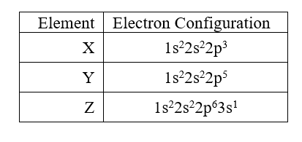
- What is the typical charge of an ion of …
    - Element X

    - Element Y

    - Element Z

- What compound would X form if bonded with …
- Mg
- Li
- Fe³⁺
- Z

- Name another element that would bond with X similar to …
- Mg. Explain your reasoning.
- Li
- Z

Topic 4.1: Introduction for Reactions

- Write and balance the equations for the following chemical reactions.

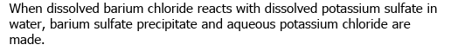

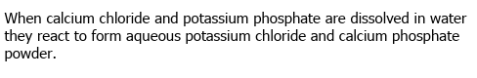

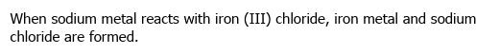

Topic 4.2: Net Ionic Reactions

- List all the solubility rules and be sure to indicate all the items that are always soluble.

